In recursion we take decisions which minimize the input problem.

Eg if the problem is to get a good job, then the first decision is to get a good college and then to take cs.

Design a recursive tree and then writing the code.

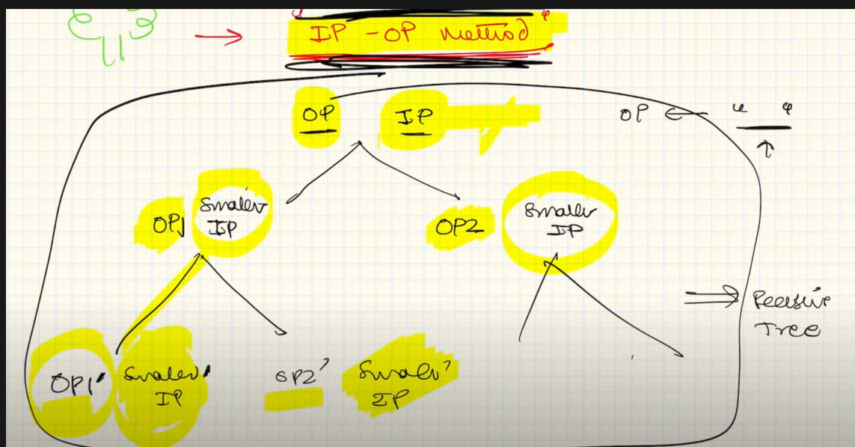

We initialize an input and output.

After every step we update output and minimize input.

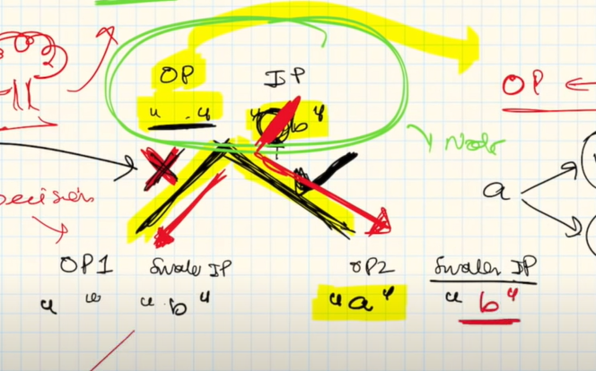

Here we take the decision on a and the output is changed. The input changes to b.

We take a decision by making a tree.

The tree is used to decide whether we want to include or not.

We make input/output strings.

Whereever we get choices we use recursion.

Recursion tree is used for decisions.

Step1 – design a tree. Step2- solve the problem.

**Hypothesis induction base condition**

This of these 3 approaches.

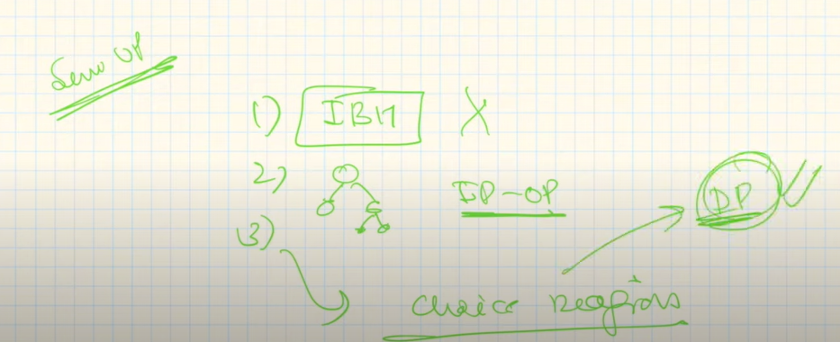

IBH is for example printing n numbers.

So we can write:

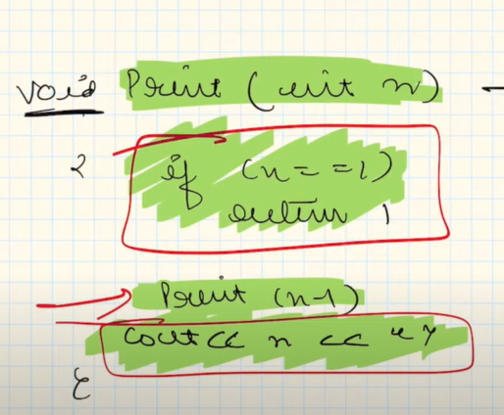

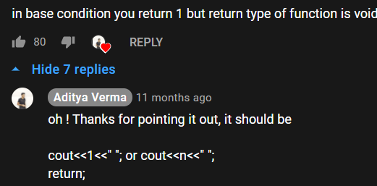

Good recursive questions are solved by recursion tree.

Easy questions are solved by IBH

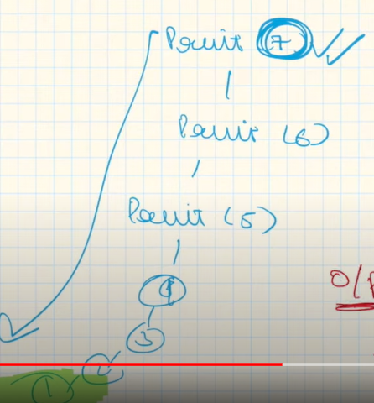

**Interesting fact**

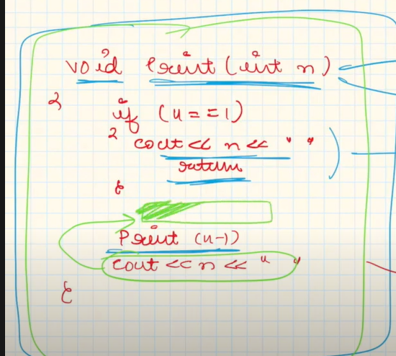

The above code prints 1 to N.

However, if we swap the statements then it prints N to 1.

**Height of a binary tree**

Step 1 is make a hypothesis function. (let us say we apply the function to a node, then that function will get us the max height for that specific node)

Step 2 is induction, once we get height of left and right subtree we add 1 to the max of either in order to get max height including that particular node on which hypothesis was applied.

Step 3 base condition.

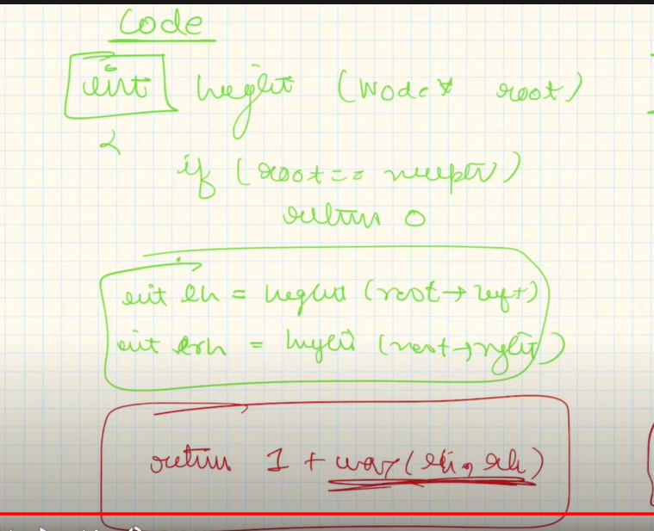

**Sort an array**

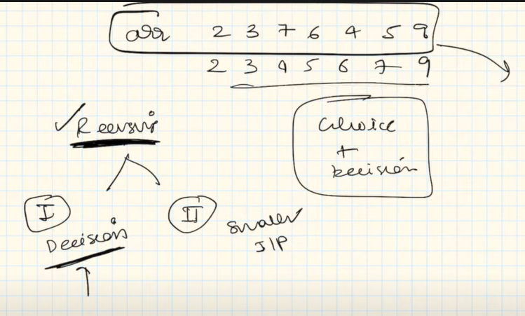

Here we try to think of decision or smaller input option. Decision is not being thought of so we go for other.

If we use decision approach we got for recursive tree method, otherwise if we want to go for smaller input option we will try to make the format of base condition, hypothesis and intuition.

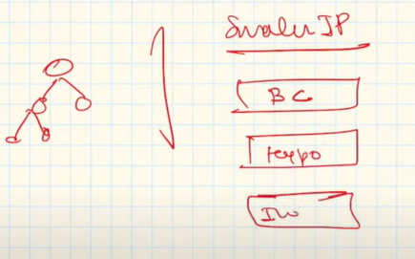

So now its time to generate base condition which comes from hypothesis.

Our hypothesis is to reduce the size of the array each time and get the sorted of its previous one.

Hence base condition is when size = 1 return array.

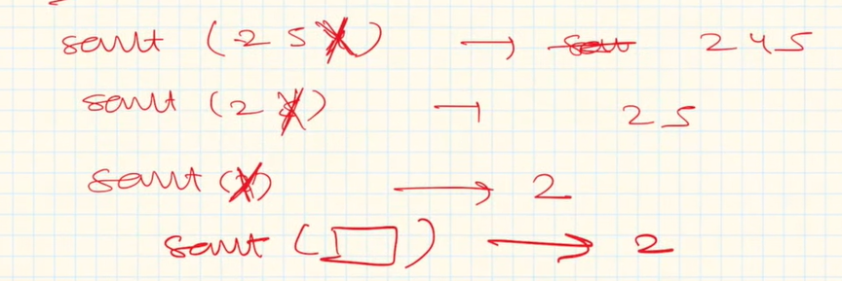

Now in induction step we have to place the 2 which is left after the previous array is sorted using recursion. (1502 -> 015 excluding 2 because we perform on n-1)

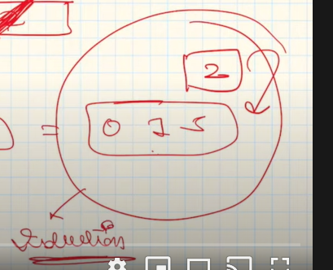

Either we can finish the problem here by applying for loop to sort the vector which we get after including the nth element. Or we can use recursion.

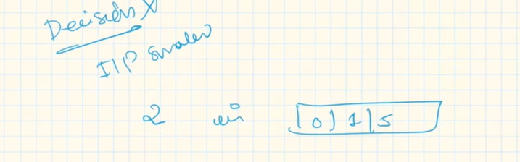

Now we have to insert 2 in this array.

Hence we reduce input by removing 5.

We remove 5 and add 2 then 5 is added again.

Base condition will be when array is empty and we don’t need to compare 2 with anything and just push or the rightmost element of the vector is smaller than the element to be inserted.

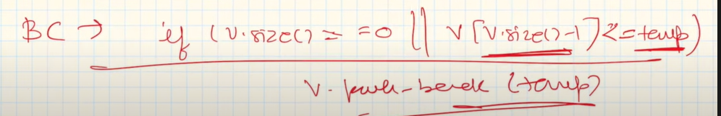

Final

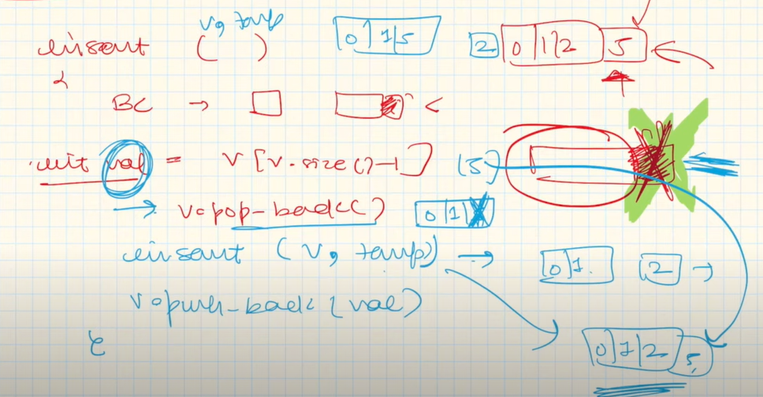

Here we first write base condition, then the value 5 is stored in val, then pop is performed to remove five. Then we push the remaining array with 0,1 and insert 2. V_pushback inserts 5 again and done.

Induction steps total = 2

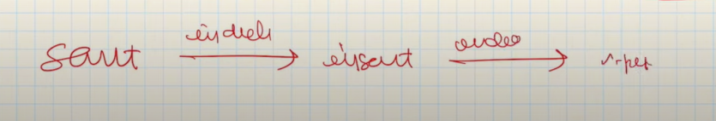

Last term is v_pushback.

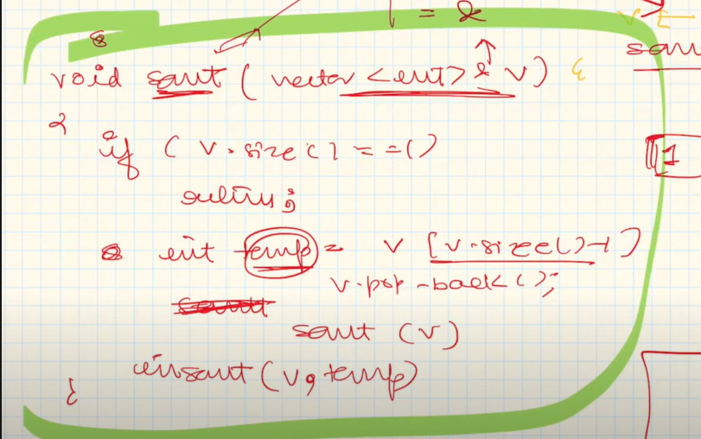

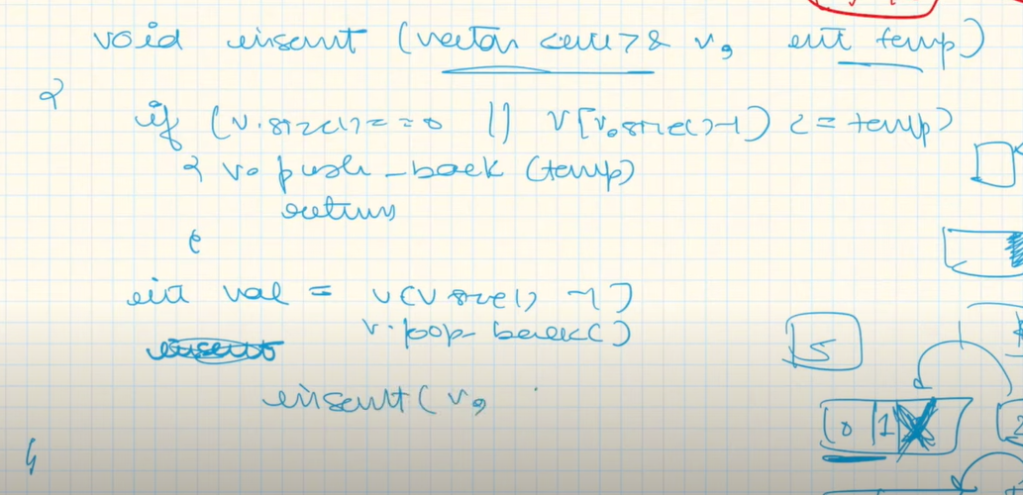

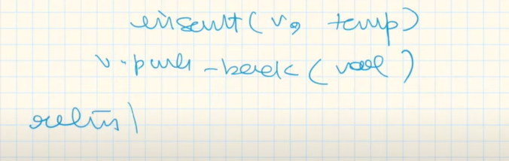

Or this code:

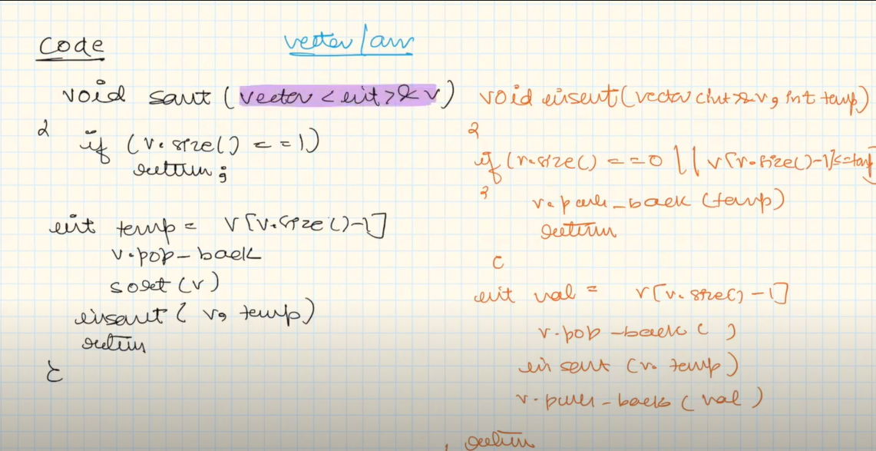

**Sort a stack**

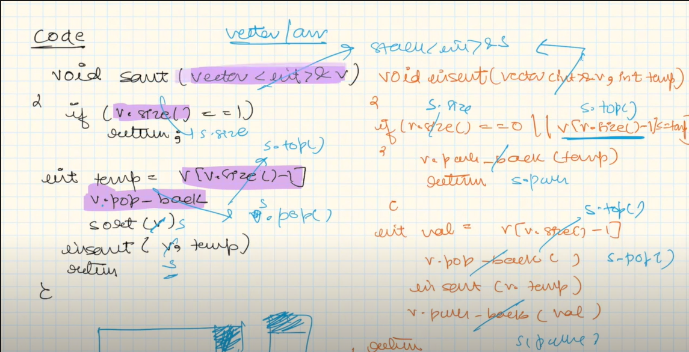

**Delete middle element of stack**

Go for smaller input.

We remove an element and pass the rest of the stack, until the k becomes 1 and we reach the element to be popped which is popped and then rest elements are pushed.

Base condition: if k == 1 pop;

Induction: push the element other than the element to be deleted which were popped

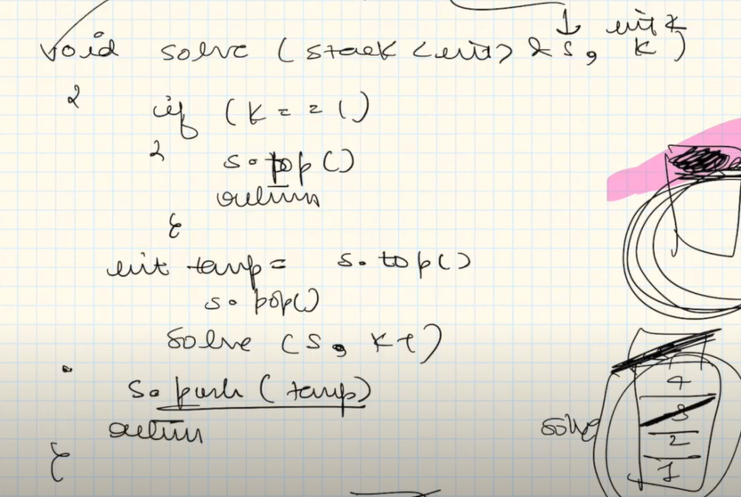

Second last line is induction.

Third last line is recursion.

First line is base.

**Reverse a stack**

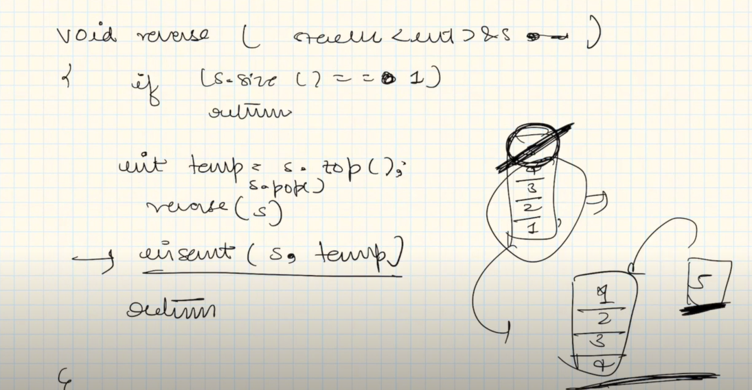

This insert is the induction step for this recursion. (we popped 5 and reversed rest of the stack, now we wanna push 5 to last).

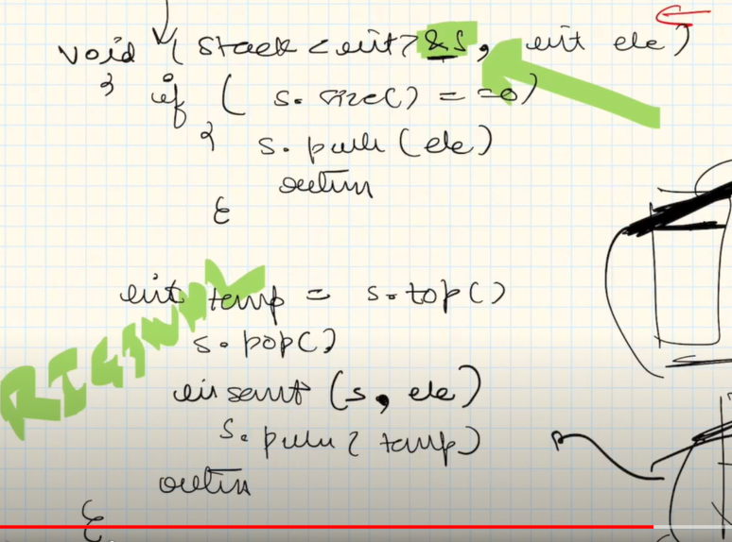

**Kth symbol in grammar**

We have to generate grammar.

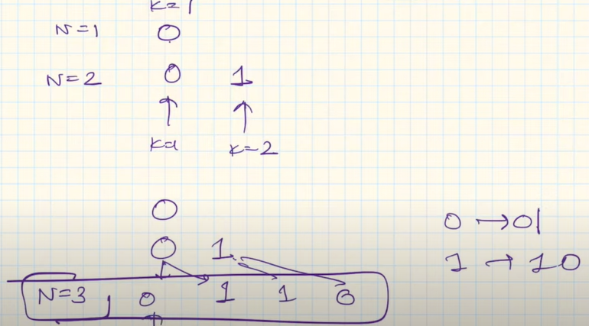

We have to return the kth element in n row.

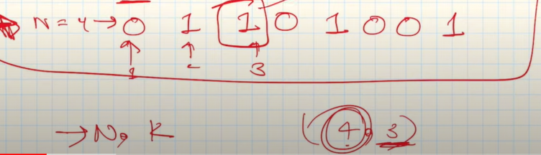

**Solution**

Induction mode mein jo hume chote recursion se answer mila uska thoda modify karke final ans mein daaldena.

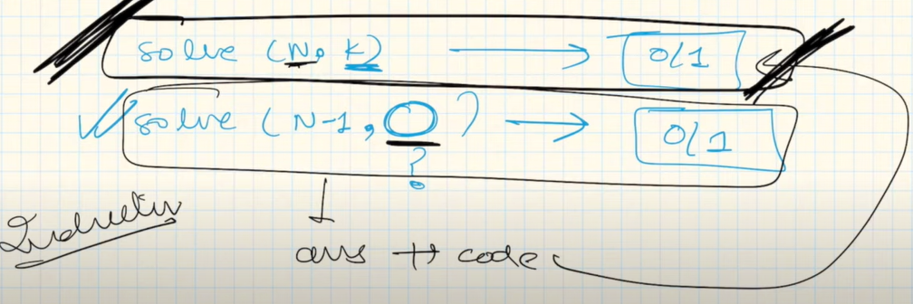In this question even if we reduce n to n-1 to perform recursion, we cannot do the same to k because it might be possible that k-1 doesn’t exist in previous.

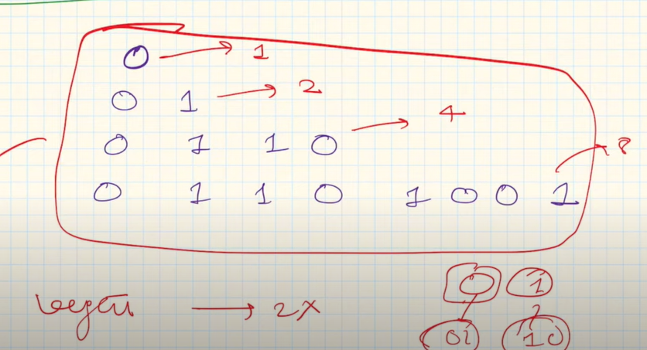

We can see length is doubled.

Here we can see that the first half is always equal to the previous string and the second half is always equal to the inverse of the previous string (0->1 and 1->0).

Induction step

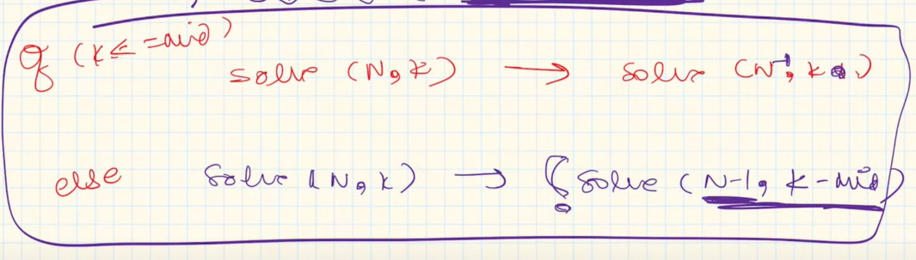

This is because if k is less than mid then it is present in earlier string. If it is greater than mid then k-mid.

**Code**

If(n==1 && k==1) // **base condition**

Return 0;

int mid = pow(2,n-1)/2;

if(k<=mid)

return solve(n-1,k); // k because it lies in the above string aswell if less than mid

else

return !solve(n-1,k-mid); // if greater than mid then its gonna be !of its first half

**Tower of Hanoi**

Transfer disks from one pole to other and they should be in ascending order from bottom to top.

Our basic task is to move n-1 disks from source to helper (recursion) and put the remaining largest disk on destination (intuition).

Base condition is when the source contains 1 disk we push it to destination.

In first recursion we take use of helper to put our n-1 disks while in the 2nd recursion the source acts as the helper to put our n-2 disks.

Base condition

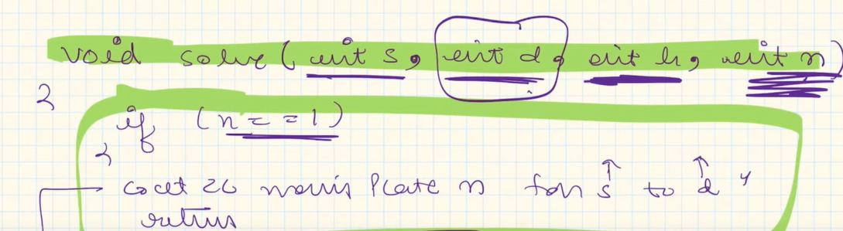

Hypothesis (reducing) and induction(printing)

In this we use helper for help to store n-1 disks.

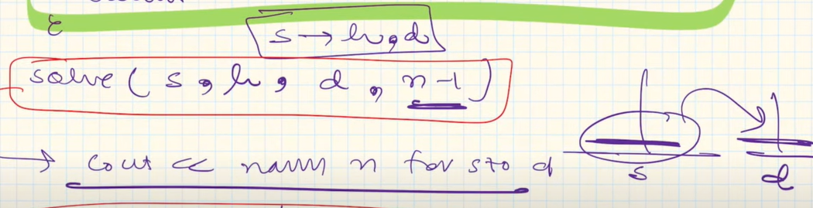

In this we use source as help to store n-1 disks.

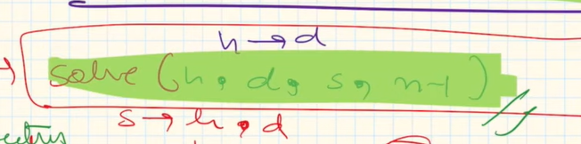

**Input/output method questions**

**Print subsets**

The approach used is as follows where we either include or exclude a term.

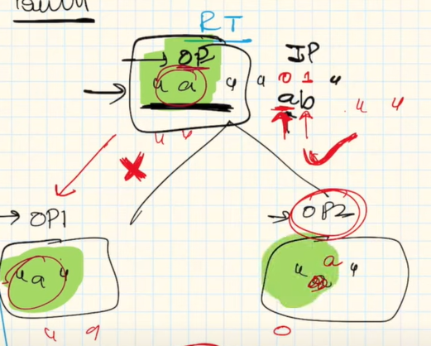

**Code**

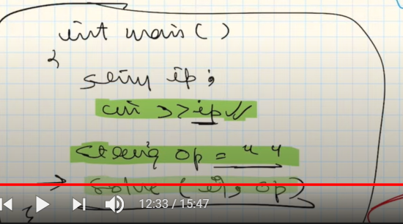

Base condition (because if input is 0 means output is achieved)

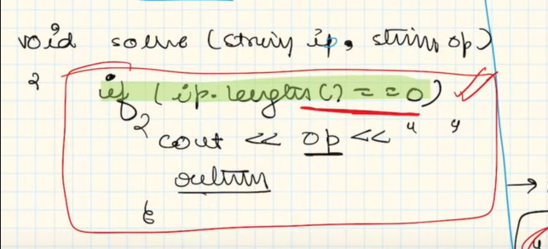

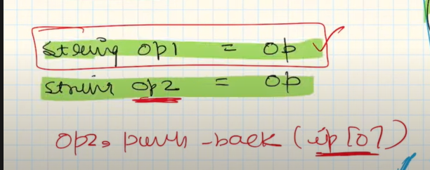

Output 1 is same because no addition but in 2 we add the first char.

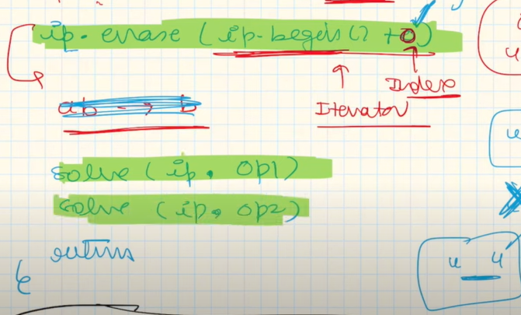

Now we erase the beginning character of input(hence input size is reduced) and then recursion is called on both op1 and op2.

**Print unique subsets and variations**

Now let us say in the last question the input was “aab”.

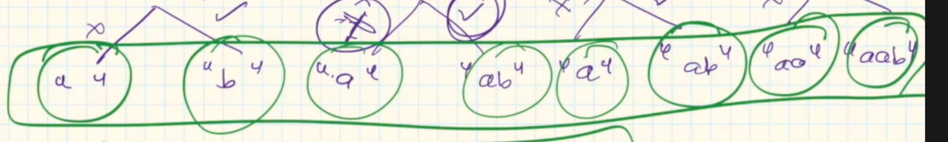

Hence we see repetition.

So in this we make a map and if the map doesn’t contain the term only then add.

Variations of this questions are print all subset, power set and subsequences.

In substring the order is consecutive and maintained.

In subsequence order needs to be maintained.

Subset no restriction.

**Permutation with spaces**

We are given a string ABC and we have to insert blank spaces between A and B or A and C or both.

ABC,A BC,AB C, A B C.

Hence these 4 combinations.

We have a choice to make whether to include the space or not.

Use recursive tree (input-output method)

The choices are whether to include the alphabet or include alphabet with the space.

However, here is a twist.

In the initial case we cannot have the option of including A with a space as we can only include spaces between letters.

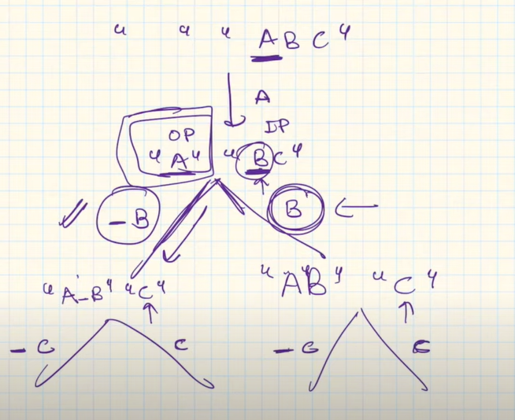

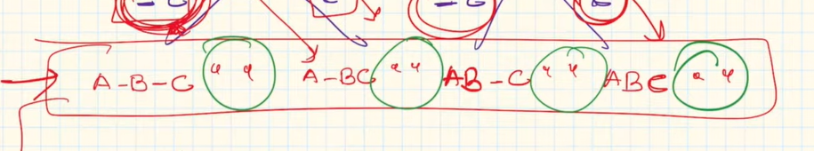

We get outputs at leaf nodes where condition is that input string becomes null.

To overcome the change here that first character is to be included without a starting space we just add the first character of the input string to output.

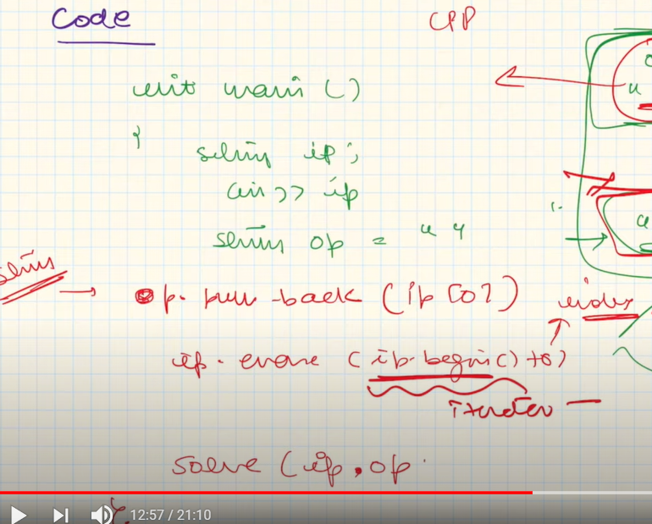

In int main we can see we have pushed first char of input to output and deleted it from input.

BASE CONDITION: when input length = 0

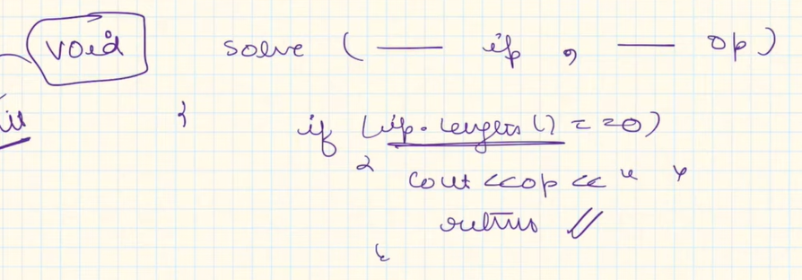

Now we make two outputs 1 without space and other with space. Then we add the first index of input string to both. Now we erase it from input.

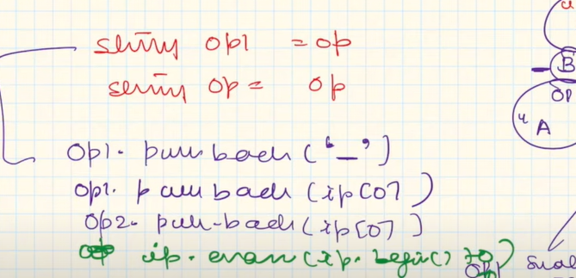

Now we call recursion:

Solve(ip,op1);

Solve(ip,op2);

Return;

|

**Permutation with case change**

We will always be given small letter alphabets.

Eg ab: print ab,aB,Ab,AB.

Then output1 will take lower of first index and output2 will take capital of first index.

Remove first index element from input string.

BASE CONDITION

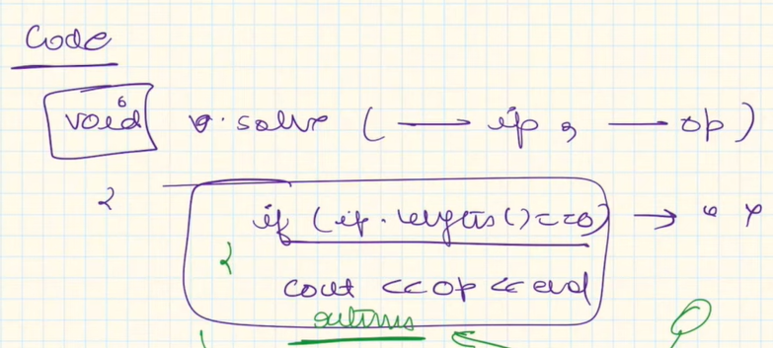

If we forget to return then the below code will run even after reaching the base condition when input string length is 0 and we get segmentation error(as no ip[0[ exists)

Making 2 outputs and adding accordingly. Removing from input. (here for op1 we don’t apply any method because input is assumed to be lowercase but for op2 we apply to_upper).

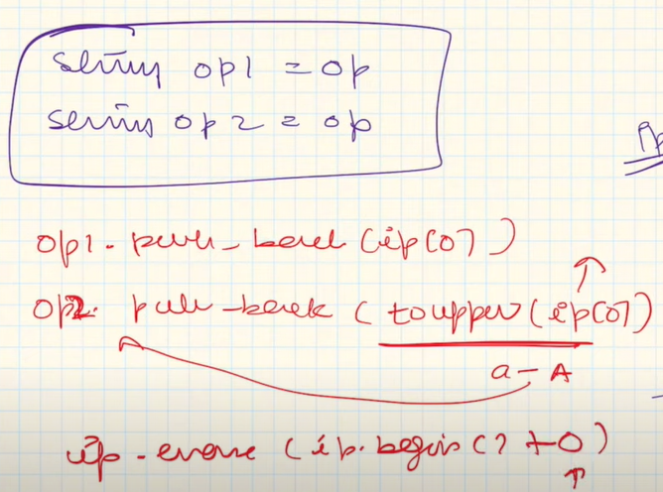

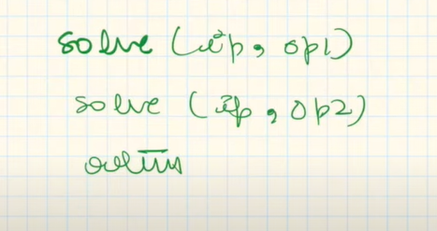

**Letter case permutation**

Unlike previous question here the input can haven uppercase letter aswell and also digits are included.

Eg: a1B2 -> a1B2,a1b2,A1b1,A1B2.

Here we have to apply a function for op1 aswell (toLower) because input can contain upper.

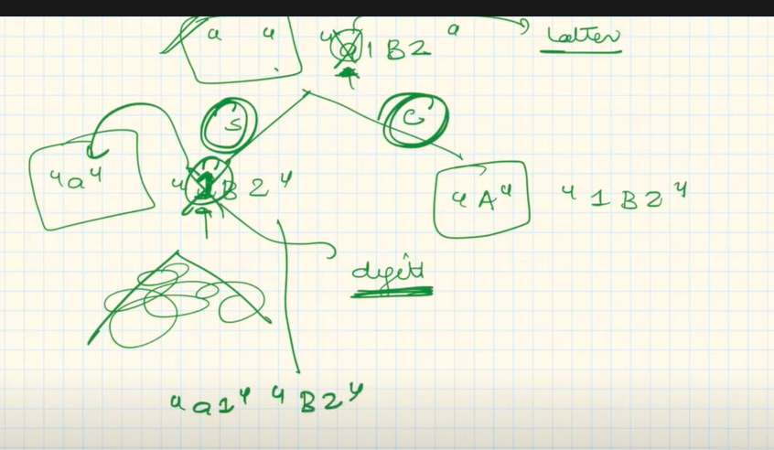

Here if alphabet we have 2 choices but for number 1 choice.

CODE (here we don’t print the code but add vector)

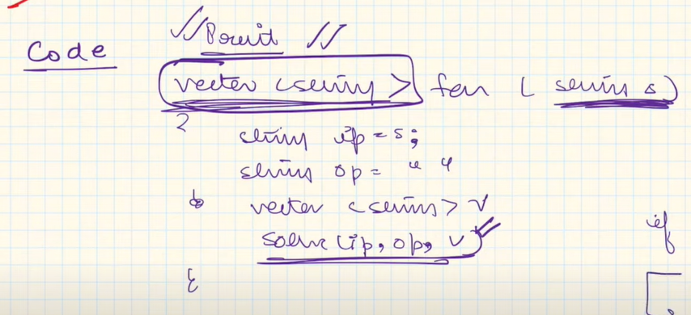

Return v; (in main)

We pass by reference in solve so that the reference is same and all the changes are made to the main vector.

BASE CONDITION

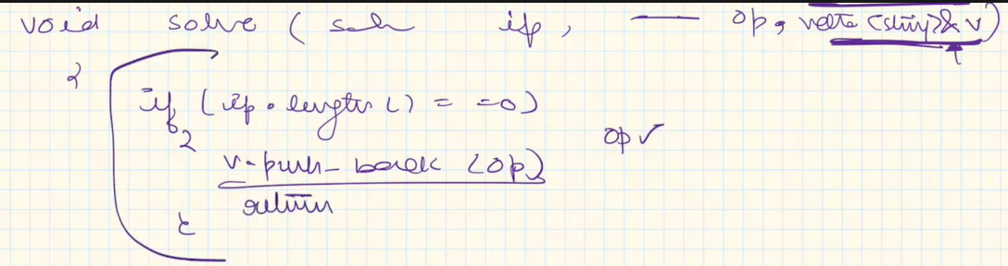

Condition 1: input is letter

If(isAlpha(ip[0])

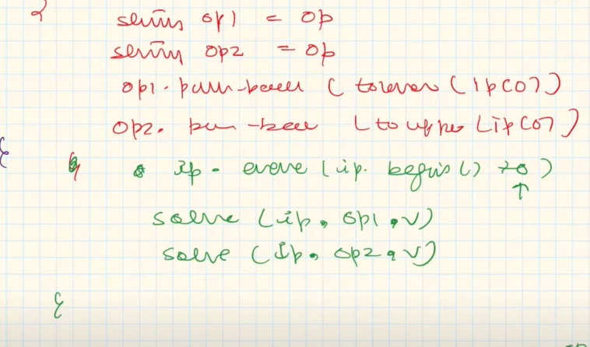

Case 2: input is number

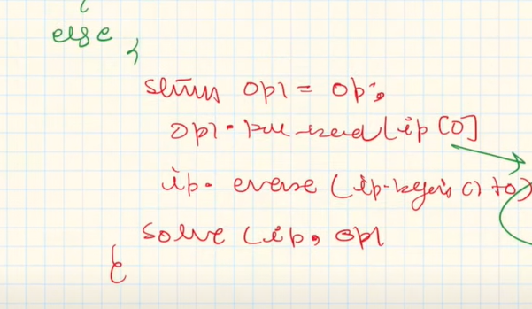

**Generate all balanced parenthesis**

Eg for n=2 -> (()), ()()

Output -> vector<string> with valid outputs.

Here we have choices and decisions hence recursion.

This is extended input/output because the format of input and output is different.

Input is a number digit whereas output is a string.

Here leaf node open/closed brackets =0.

At every point we have the choice of adding an opening bracket (unless its 0) whereas the choice of closing brackets exists only when number of input brackets added is greater than closed.

(or we can say when available number of closed brackets > input brackets)

Code

Int function

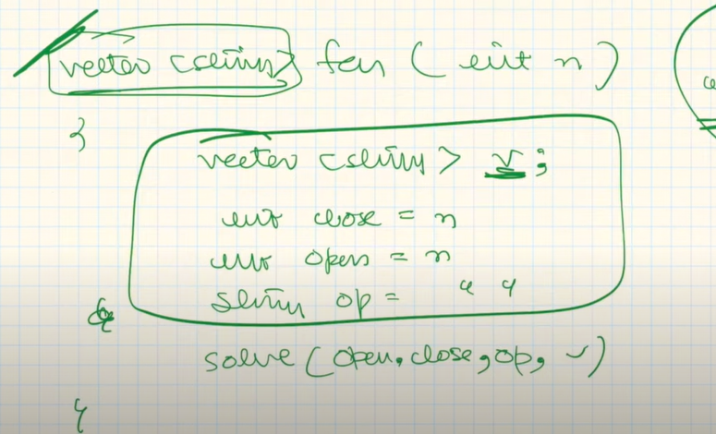

We don’t need to print anything just store it in vector so use reference. (hence used void)

BASE CONDITION

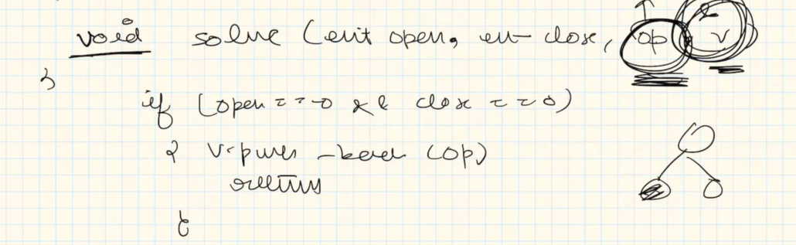

Now for opening bracket we have the choice of inserting it till its count = 0.

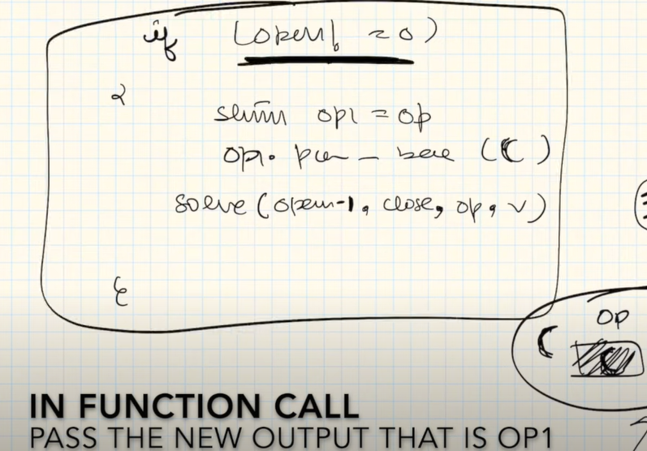

For closing brackets we only have choice when number of available closing brackets is greater.

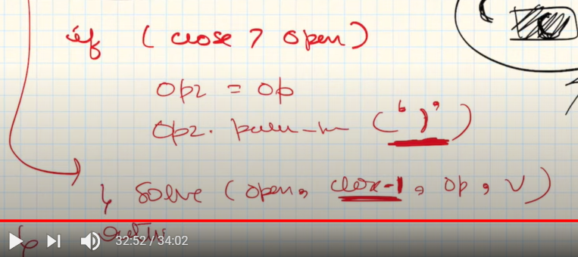

**Print N-bit binary numbers having more 1’s than 0’s for any prefix**

If we are given n = 5, we have to generate all possible patterns where number of 1 is greater = than 0 for prefix.

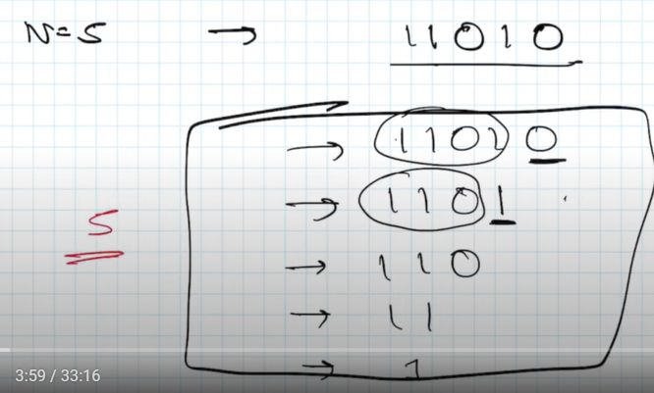

The recursion will be over when n turns to 0.

In below ss we can see first we take 1 because if we take 0 it will be false for case1.

After the 1st 1 we change one – 1 and N – 2.

Now we can use either 1 or 0.

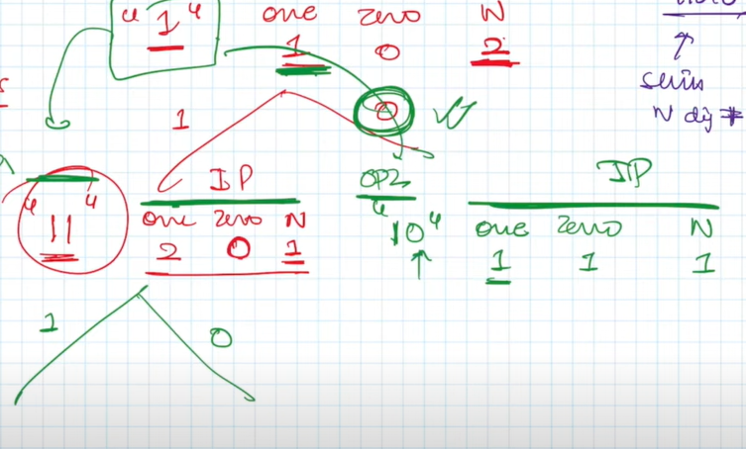

In complete ss below we can see that choice for 1 is always available.

Choice for 0 is only possible when number of existing 0 is less than number of existing 1.

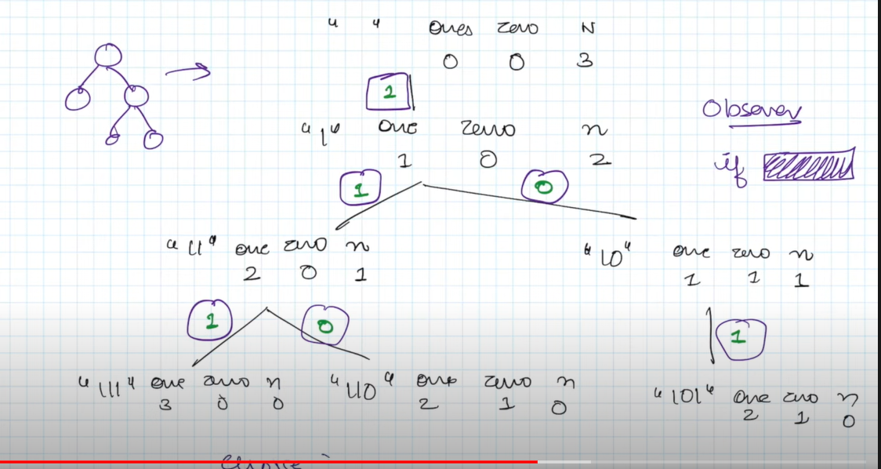

CODE

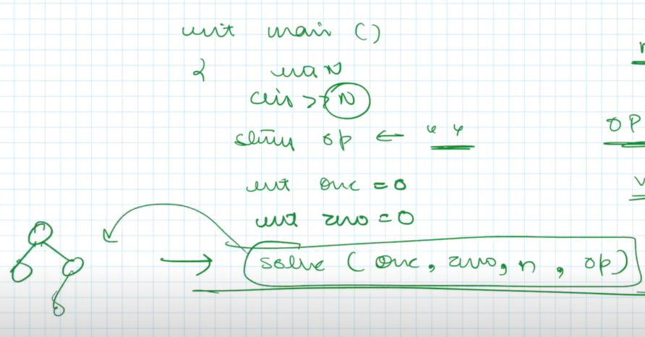

We use void solve because we will print.

Here one and zero in the main function indicates the number of 1 and 0 used.

BASE CONDITION

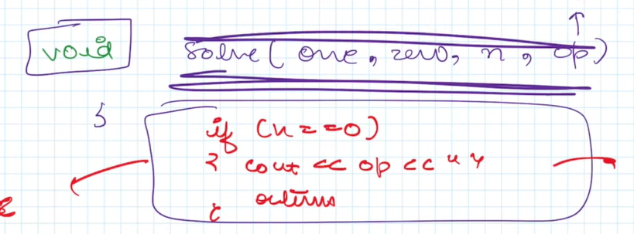

As we know theres no condition to enter 1 as we can directly add it.

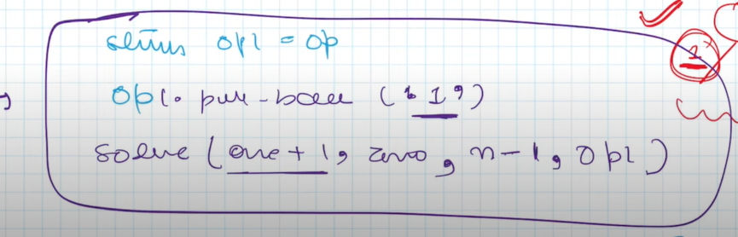

For 0 we will only allow when number of 0s added is less than 1.

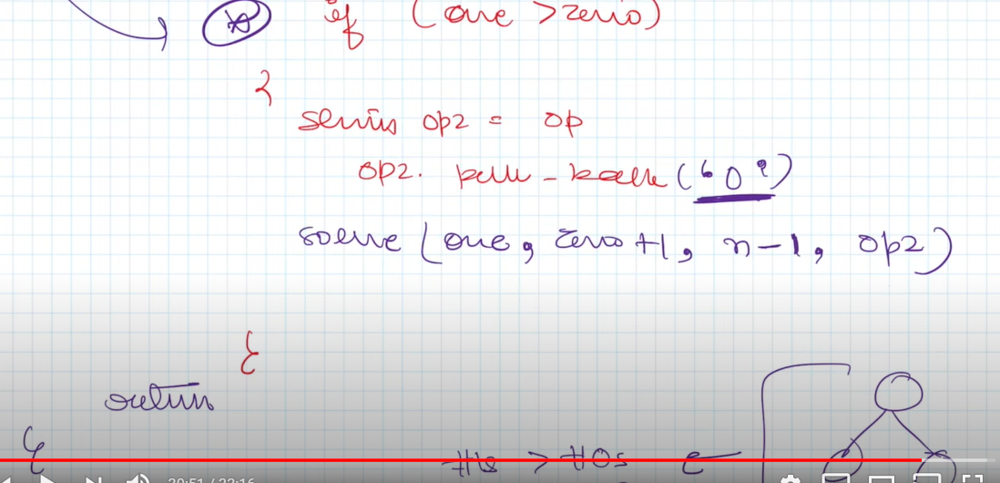

**Josephus problem**

N = total number of people

K = counting done at which person is killed

This problem is recursively defined because the word done is same everytime only n reduces.

These type of recursively defined problems are solved using IBH method and decision problems are solved using tree.

In ibh we first decide hypothesis. Now same hypothesis is made for smaller input. Then base condition. Finally induction.

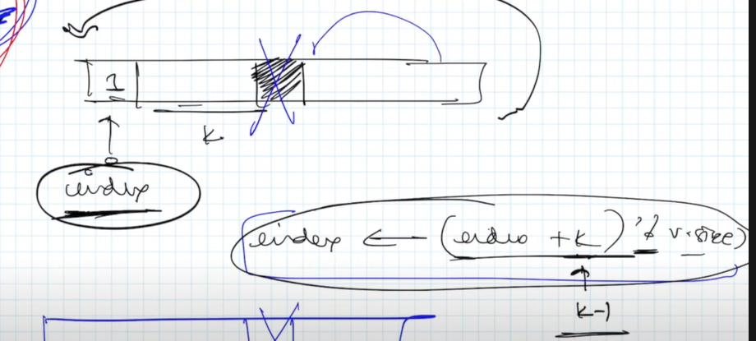

In this we delete like this.

In this when we kill a person we reduce array size by 1.

However if we remove size by 1 we will delete the last element which might not be the person that we wanted to remove. Hence we store it in a temp variable and later use induction for adding it.

Meanwhile we have to remove the person which was supposed to be and it will be never added in future.